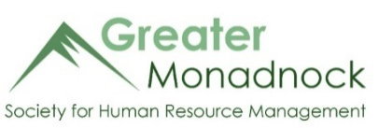

Greater Monadnock Society for Human Resource Management
Monthly Chapter Meeting Sponsor
Payment Form

Meeting Being Sponsored ______________________________________________________
Company Representative _______________________________________________________
Company Name _______________________________________________________
Address _______________________________________________________
City, State Zip _______________________________________________________
Email Address _______________________________________________________
Phone Number _______________________________________________________

Please make $350 payment via check to the address below or via credit card on our website
Signature |  | Date

For GMSHRM Use:
Payment received: Date: ____/____/____ $_____________________ Check # ___________ Credit card Cash

Information entered into database Date: ____/_____/_____

GMSHRM Chapter # 683 - P.O. Box 1817 - Keene, NH 03431
www.monadnockshrm.org greatermonadnockshrm@gmail.com

